# Exercise 1: Implementing the Singleton Pattern

class Logger {

    private static Logger instance;

    private Logger() {

        System.out.println("Logger initialized.");

    }

    public static Logger getInstance() {

        if (instance == null) {

            instance = new Logger();

        }

        return instance;

    }

    public void log(String message) {

        System.out.println("LOG: " + message);

    }

}

public class Singleton{

    public static void main(String[] args) {

        Logger logger1 = Logger.getInstance();

        Logger logger2 = Logger.getInstance();

        logger1.log("First message.");

        logger2.log("Second message.");

        if (logger1 == logger2) {

            System.out.println("Only one instance of Logger exists. Singleton confirmed.");

        } else {

            System.out.println("Multiple instances detected. Singleton failed.");

        }

    }

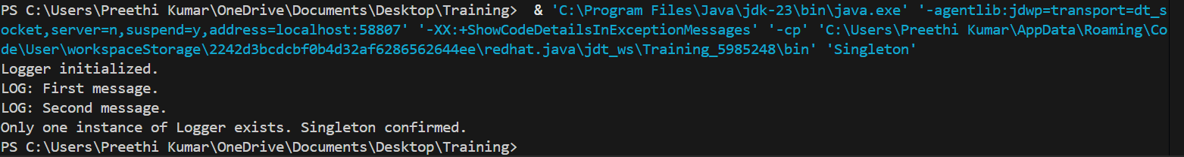

# Exercise 2: Implementing the Factory Method Pattern

interface Document {

    void open();

}

class WordDocument implements Document {

    public void open() {

        System.out.println("Opening a Word document...");

    }

}

class PdfDocument implements Document {

    public void open() {

        System.out.println("Opening a PDF document...");

    }

}

class ExcelDocument implements Document {

    public void open() {

        System.out.println("Opening an Excel document...");

    }

}

abstract class DocumentFactory {

    public abstract Document createDocument();

}

class WordDocumentFactory extends DocumentFactory {

    public Document createDocument() {

        return new WordDocument();

    }

}

class PdfDocumentFactory extends DocumentFactory {

    public Document createDocument() {

        return new PdfDocument();

    }

}

class ExcelDocumentFactory extends DocumentFactory {

    public Document createDocument() {

        return new ExcelDocument();

    }

}

public class FactoryMethod {

    public static void main(String[] args) {

       DocumentFactory wordFactory = new WordDocumentFactory();

        Document word = wordFactory.createDocument();

        word.open();

        DocumentFactory pdfFactory = new PdfDocumentFactory();

        Document pdf = pdfFactory.createDocument();

        pdf.open();

        DocumentFactory excelFactory = new ExcelDocumentFactory();

        Document excel = excelFactory.createDocument();

        excel.open();

    }

}

